**EXPERIMENT-7**

Name: Aditya Agarwal  
Sap id: 500069294  
Roll no:R171218007

**CREATE A PIPELINE USING BLUE OCEAN.**

1) To create a pipeline using Blue Ocean we need to download.

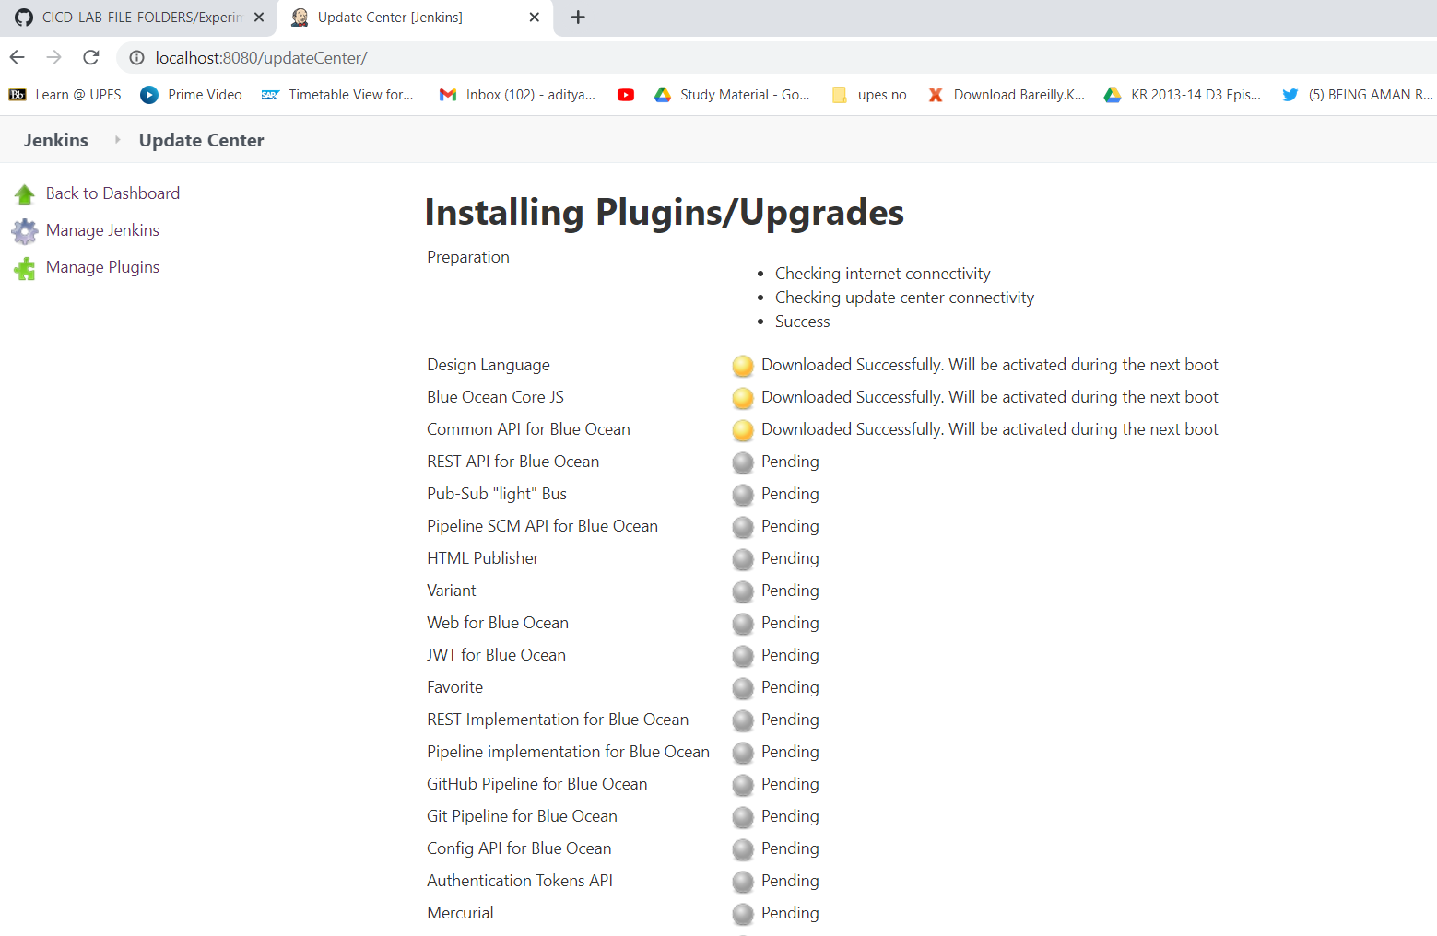

Select Open Blue Ocean and create a new pipeline.

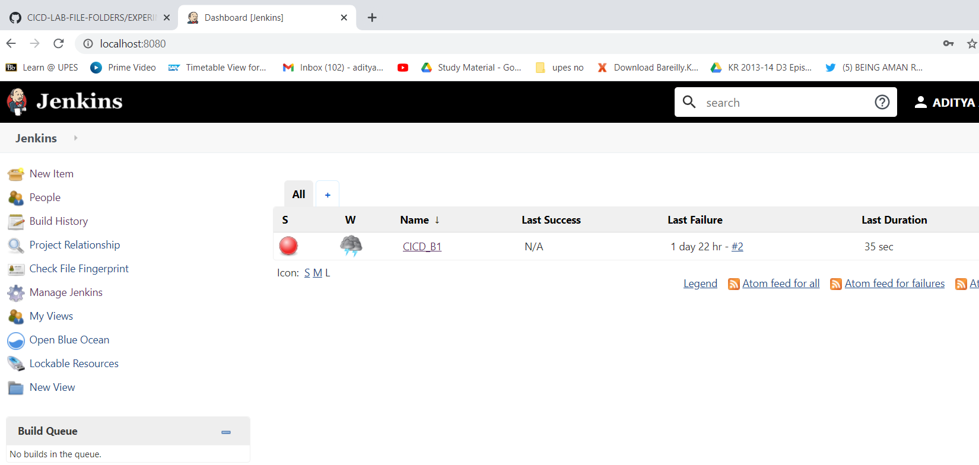

Select Git as the SCM manager for the project

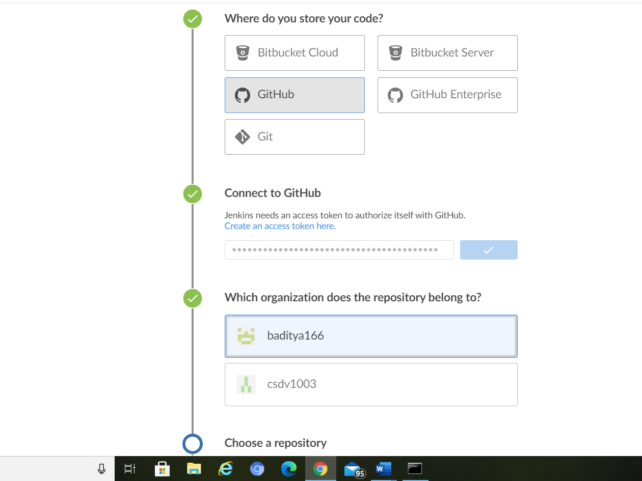

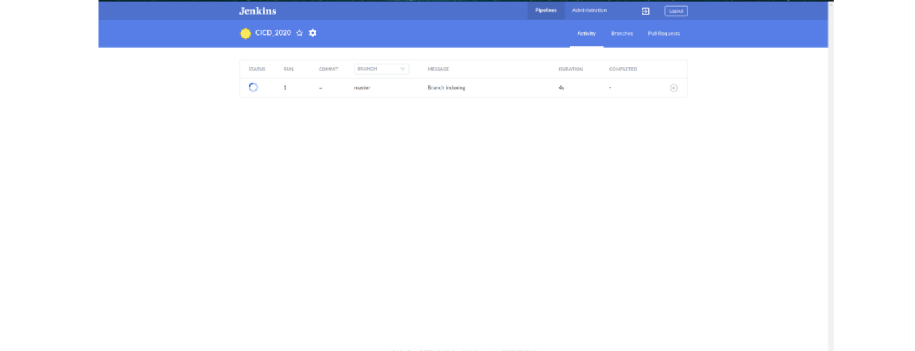

Pipeline completes successfully

